
BUAN 6390.S02
ANALYTICS PRACTICUM

CASE STUDY INTERIM REPORT

Submitted By:
- Megha Chandrasekharan Nair | | | MXC220113
- Noah T Brown | | | NXB230027
- Vishala Vemuri | | | VXV230006
- Sriram Ganeshalingam | | | SXG240054
- Teja Kuragayalabathi | | | txk230037

TABLE OF CONTENTS

1. Problem Statement …………………………………………………………………… 3
2. Design Conditions and Boundaries ………………………………………….. 3
3. What Success Looks Like ………………………………………………………….. 3
4. Information Asset Inventory …………………………………………………….. 4
5. Our Proposed Solution ……………………………………………………………… 5
6. Hypothesis to Back Up Our Idea ……………………………………………… 6
7. Key Features of Our Business Model ………………………………………. 9
8. Revenue Streams …………………………………………………………………….. 10
9. Direct and Indirect Competitor Analysis ………………………………….. 10
10. Go-To-Market Strategy ……………………………………………………………… 11
11. Marketing and Sales Strategy …………………………………………………. 13
12. Market Size and Opportunity …………………………………………………… 13
13. Metro-Level Market Analysis …………………………………………………… 13
14. Forward Outlook ………………………………………………………………………… 18
15. Projected Acquisition Volume & Capital Requirement …………… 18
16. Conclusion ………………………………………………………………………………… 18
17. Next Steps …………………………………………………………………………………. 19
18. Project Phase 2 – Implementation …………………………………………… 20
19. Forecasting Economic Indicators ……………………………………………… 20
20. Metro Finalizations ……………………………………………………………………… 21
21. Subscription-Based SmartSell Platform ……………………………………… 23
22. Primary KPIs Ranked ………………………………………………………………….. 25
23. Cost Analysis and Financial Statements …………………………………….. 26
24. Acquisition and Profitability Model ……………………………………………. 26
25. Marketing Outline ………………………………………………………………………. 29
26. Financial Statements ………………………………………………………………….. 31
27. Individual Contributions …………………………………………………………….. 34
28. Code and References …………………………………………………………………. 34

PROBLEM STATEMENT

The U.S. primary-home market is loaded with underlying friction and emotional burden: sellers and buyers alike encounter long, opaque processes, cost overruns, and stress-inducing interactions. For many sellers, the experience is worse than major life events - 62% say it affects their mental health [1]. Meanwhile, buyers face rising transaction costs, limited transparency, and lack of post-sale support. The result: home ownership becomes less accessible, less trusting, and less sustainable.
Contents
No table of contents entries found.
Why this matters?
Sellers are willing to accept lower proceeds just to avoid stress and burden. That signals a valuable opportunity for a smoother process.
- Buyers and sellers both face hidden costs, long prep periods and showings. Your business can intervene there.
- The emotional toll underscores the reputational and ethical dimension - you’re not just optimizing transaction speed; you’re reducing human burden.
- The data legitimizes the need for customer-centric innovation: this isn’t a fringe issue, it’s widespread.

Given the understanding of our customer pain points - How might we create a home buying & selling solution that transforms the emotional, financial, and operational pain inherent in today’s market into a streamlined, transparent, and mutually beneficial journey - while achieving sustainable profitability, ethical standards, and predictable growth over a 2-year horizon?

DESIGN CONDITIONS AND BOUNDARIES

Given a committed investor with $500 M in operating capital and access to up to $10 B in liquidity, we have the strategic and financial capability to re-architect this process. Our goal is to deliver a fast, fair, and transparent primary-home buying and selling platform in the U.S. - one that minimizes stress and hidden costs, prioritizes ethical profit sharing, and delivers long-term value for both homeowners and investors.
Constraint | What It Means for Our Solution
U.S. only | Prioritize markets we can understand & operate in responsibly
Launch by Dec. 15 | Design must be executable this year, not theoretical
Primary homes only | Focus on people, not real-estate speculation
Short sale cycle | Houses must be bought & sold quickly to ensure liquidity
Post-sale support | Customer trust and satisfaction must extend after closing
Controlled spending velocity | Prioritize unit economics and operational discipline

WHAT SUCCESS LOOKS LIKE AS DEFINED BY THE STAKEHOLDER

- Transform home buying from a stressful transaction to a guided, supported journey
- Maintain sustainable margins while scaling responsibly
- Enable shared equity and a cooperative approach with sellers that enables both parties to profit.
- Establish the brand as a trusted, ethical alternative to traditional agents and existing iBuyers.

INFORMATION ASSET INVENTORY

This Information Asset Inventory outlines the key internal and external datasets that power our business operations, their relevance to business strategy, and how they contribute to differentiation.
Category | Examples | Explanation
Operational datasets (Highest relevance) | • Property listings (marketplaces)  • Home valuation & appraisal data  • Renovation costs & contractor bids  • Offer-to-sale conversion logs  • Inventory turnover & holding cost data | Core operational assets for buy-renovate-resell cycles. Enable dynamic pricing, cost control, and ROI forecasting.  Sources: Internal offer systems, MLS feeds, renovation partners, financial ledger.
Competitive analysis & Commercial datasets | • Competitors and their SEO Filings  • CoreLogic / ATTOM real estate data  • Redfin, Realtor.com pricing indices  • Moody’s, CoStar, Freddie Mac housing reports | Used to benchmark acquisition prices, assess competitor coverage, and identify emerging metro opportunities.  Sources: Paid data APIs (CoreLogic, CoStar), competitor tracking dashboards.
Market & Consumer Survey Data | • Historical housing market data  - Buyer and seller satisfaction surveys  • NPS, referral rates, and offer acceptance  • Realtor & contractor feedback | Captures sentiment and pain points across users and partners. Helps refine pricing algorithms and improve user experience.  Sources: Sentiment analysis data, survey tools, post-sale feedback forms.
Public datasets - contextual, secondary to proprietary insights | • Census demographics & migration patterns  • Economic indicators (unemployment, wage growth)  • Mortgage rates, housing starts  • Climate & disaster risk data | Provides macro context to refine metro-level stability scores and identify sustainable high-growth regions. Guides capital allocation and risk-adjusted portfolio planning.  Sources: U.S. Census Bureau, BLS, FRED, Freddie Mac PMMS, FEMA.
Social & Behavioral Data | • Web clickstream & traffic analytics  • Paid ad performance metrics  • Social listening data (Twitter, Reddit, TikTok)  • Local neighborhood sentiment trends | Tracks brand visibility, sentiment toward “instant sale” concepts, and regional seller intent signals. Early detection of shifts in consumer perception supports proactive marketing adjustments.  Sources: Google Analytics, Brandwatch, Meta Insights, Reddit APIs.
Geospatial & Property Intelligence Data | • Satellite imagery (e.g., Roof condition, lot boundaries)  • Parcel maps and zoning data  • School, commute, crime, and amenity scores | Improves AVM accuracy and resale potential scoring by blending physical, locational, and lifestyle attributes. Essential for neighborhood-level valuation models.  Sources: OpenStreetMap, ESRI, Zillow Neighborhood APIs, Google Places.

OTHER ASSETS:
Potential Asset | Examples | How It Uniquely Helps our Business
Renovation Performance Data | • Contractor bids, project timelines, cost variance | Builds metro-specific renovation cost benchmarks to decide when to renovate vs. list as it is.
Mortgage & Lending Partner Data | • Buyer pre-approval trends, cash offer ratios | Strengthens bridge and cash-backed offer programs, reducing transaction friction.
Seller Persona Data | • Household tenure, equity position, delinquency indicators | Predicts seller motivation and enables personalized outreach with accurate offer timing.
Energy & Sustainability Data | • Utility efficiency scores, solar adoption | Adds ESG differentiation and aligns with green financing options.
Vendor & Supply Chain Data | • Material lead times, vendor reliability | Reduces carrying costs and improves renovation scheduling accuracy.
Neighborhood Velocity Index (Derived) | • Rolling 6-month price and DOM turnover | A proprietary measure of resale velocity, guiding buy-box prioritization and exit timing.

OUR PROPOSED SOLUTION

“SmartSell”: Smarter Home Trading for Modern Homeowners

The Problem We’re Tackling
Most homeowners don’t realize that in the first 8 - 10 years of their mortgage, most of their payments go toward interest, not equity. So when life changes - a new job, relocation, or growing family, they often sell early, expecting profit that never materializes. Even in appreciating markets, many end up losing money because of:
- Overestimating equity and underestimating loan amortization.
- Selling too soon, without understanding the financial impact.
- Hidden costs like fees, commissions, and opportunity costs that are rarely explained upfront.
- Limited guidance or transparency from agents and brokers who focus on closing, not long-term financial outcomes.
SmartSell would:
- Deliver personalized guidance on the best timing to sell, using mortgage amortization schedules, market forecasts, and the homeowner’s life plans. Introductory service provided for first time customers to build trust and highlight the benefits of our subscription model, encouraging them to stay with us until that best time comes and remain with us after.
- Present transparent, visual cost breakdowns-principal vs. interest, transaction fees, and projected equity gains or losses.
- Enable direct sale or trade-in transactions within the platform, combining iBuyer-level convenience with superior financial clarity and decision support.
- Offer value-added services such as maintenance, moving coordination, and post-sale support to reduce friction and stress.
- Build a trusted community of homeowners, empowering them through shared experiences while strengthening loyalty and long-term engagement.

Why It’s Different
Where existing instant-offer platforms (like Opendoor or RedfinNow) focus on transaction speed, SmartSell focuses on financial clarity and user empowerment.
It bridges the gap between financial literacy and real estate execution - helping homeowners make confident, data-driven decisions about one of their largest assets.

HYPOTHESIS TO BACK UP OUR IDEA
To validate the financial risk and customer pain associated with selling primary homes early, we analyzed a large-scale U.S. mortgage and property dataset sourced from the 2024 publicly available Loan Application Register (HMDA) [2] dataset. This dataset contains loan-level characteristics for real residential mortgage originations nationwide. The dataset includes:
- 12,229,298 mortgage records covering all U.S. states and counties
- Key fields such as: Loan amount, Interest rate, Loan term, Property value, Loan purpose, Owner-occupancy indicator, Lien status, Action taken (origination outcome)

Processing & Filtering
To align with our business model - primary residences purchased by homeowners, not investors; we filtered the data for:
Filter Applied | Meaning for Our Study
Loan originated = Yes | Only real purchases that closed successfully
Loan purpose = Home purchase | Excludes refinancing, home equity loans
Lien status = First lien | Standard mortgage structure
Occupancy = Owner-occupied | Properties intended as primary homes
This yielded a refined dataset of 2,882,057 primary home loan records eligible for equity analysis.
Analytical Enhancements
To understand equity and financial outcomes over time, we computed:
Derived Metric | Description
Monthly mortgage payments | Based on loan amount, interest rate & term
Remaining mortgage balance after 2, 5, 10 years | Standard amortization formula
Homeowner equity % at 2, 5, 10 years | Real retained value vs. property price
Net proceeds if sold after 2, 5, 10 years | Includes 8% transaction cost assumption
Scenarios under 0%, 2%, 4%, 6% annual appreciation rates | Tests both poor & healthy market conditions

Why This Dataset is Perfect for Our Problem
Business Need | Dataset Capability
Focus on primary homes | Occupancy, lien status, loan purpose fields
Ethical transparency in U.S. markets | Nationwide coverage across metro/county levels
Real financial outcomes | Actual mortgage structure + equity simulation
Risk quantification for early sellers | Balance & proceeds modeling across time horizons
This dataset enables us to answer the critical Design Thinking inquiry:
“Are customers who need to move early actually losing money under the current system?”
Our analysis are summarized using the graphs below and tables-
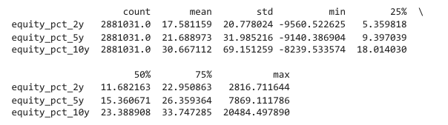
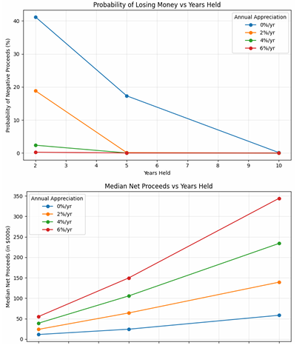
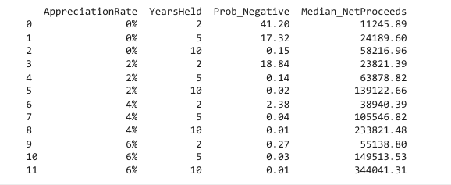
H1 - Early sellers are financially vulnerable
Hypothesis:
Homeowners who sell within the first 2 years face a high probability of negative net proceeds after transaction costs.
Evidence:
- At 0% home appreciation, 41.2% lose money selling within 2 years.
- Even at 2% appreciation, 18.84% still lose money.
- Only at a higher appreciation of 6% above do we see a decline in percentages.
Supports our solution: Provide equity-protective options (co-investment, upside-sharing, transparent costs)

H2 - Moderate holding periods still do not guarantee returns
Hypothesis:
Selling within 5 years still exposes many homeowners to unexpected losses or minimal equity.
Evidence:
- At 0% appreciation, 17.32% probability of losing money at 5 years
- Median equity % after 5 years ≈ 15%, not enough to cover life-event driven moves.
Supports ethical investment + lower commissions + fee-transparency

H3 - Most financial benefits only appear after 10+ years
Hypothesis:
Significant wealth building from homeownership is delayed until after 10 years, due to interest-heavy loan amortization.
Evidence:
- Median equity after 2 → 11.7%
- After 5 → 15.4%
- Only by 10 → 23.4%
Paired t-tests between years 2, 5, and 10 are highly significant (p < 0.000)
Supports co-investment and fair break-even pricing for early movers

KEY FEATURES OF OUR BUSINESS MODEL:
Given that we understand the customer pain points from data, we can now design our core features -
Here's a breakdown of SmartSell's core functions and their descriptions:
Function | Description
Equity Health Check | Uses amortization + market data to show a homeowner’s real equity and break-even point for selling.
Sell-vs-Hold Advisor | Predicts future appreciation vs interest cost to guide whether to sell, refinance, or stay.
Instant Sale Option | If a user decides to sell, SmartSell offers an instant cash offer (via partner investors) - just like Opendoor.
Fee-Transparent Marketplace | Removes traditional agents - buyers and sellers deal directly through verified listings with transparent 1-2% platform fees.
Data Backbone | Uses HMDA + FHFA + Redfin data to model neighborhood risk and optimal sale timing.
One stop solution application | An application that helps in maintenance, connect with a network of homebuyers, provides a knowledge transfer like course for new homebuyers, track the mortgage rates, options for capitalizing etc.

REVENUE STREAMS
Here's how SmartSell generates revenue:

Revenue Stream | Description
Service Fee | 4% fixed + variable % (vs ~6% traditional).
iBuying Spread | When SmartSell buys below predicted fair market value and resells later.
Premium Tools | Subscription for advanced equity tracking, refinancing alerts, portfolio analytics, maintenance etc.
Referral Revenue | From mortgage refinances, home insurance, or home improvement partners.
SmartSell's unit economics are designed to be attractive by offering high-value services that command fair pricing while significantly undercutting traditional alternatives. The immediate transaction fees, coupled with recurring subscription revenue and strategic referral partnerships, create a diversified and sustainable revenue model. Our iBuying spread further enhances profitability by allowing SmartSell to capitalize on market inefficiencies.

DIRECT AND INDIRECT COMPETITOR ANALYSIS

Our competitive landscape spans both direct iBuyer rivals and indirect real-estate market competitors whose offerings may divert our target customers.

Direct Competitors (iBuyer Market)
Opendoor
- Largest iBuyer and primary competitive threat.
- Strengths: Fast cash offers, strong digital/AI operations, national metro coverage.
- Weaknesses: Highly volatile financials - consistent losses, extremely sensitive to high rates and slow markets.
- Learnings: Operational efficiency + risk controls needed to avoid inventory losses.
Offerpad
- Second largest iBuyer; similar product at smaller scale.
- Strengths: Added renovations for margin improvement, more flexible hybrid services (cash + agent-based selling), better customer personalization.
- Weaknesses: Persistent losses and revenue decline → required downsizing.
- Learnings: Diversified services can provide resilience in weak markets.

Indirect Competitors (Rental, Marketplace, Build-to-Rent)
Mid-America Apartment Communities (MAA)
- Leading multifamily REIT in fast-growing Sunbelt markets.
- Strengths: Strong financial, high occupancy (95.6%), stable long-term revenue.
- Threat: Converts buyers to renters through affordability and convenience.
- Insight: High-growth southern metros = key battleground for ownership vs. renting.
Zillow
- Marketplace giant; no longer in iBuying since 2022.
- Strengths: 160M+ listings, brand ubiquity, AI-driven home discovery.
- Weaknesses: Weak profitability post-iBuyer exit.
- Role: Partner + competitor - critical for visibility but can direct demand away.
Invitation Homes
- Largest single-family rental owner; close market adjacency.
- Strengths: Stable profits, in-house maintenance, Build-to-Rent expansion.
- Threat: Competes for same homes & customers seeking flexibility vs. ownership.
- Insight: Renting in single-family space is growing - we must differentiate on ownership value.
Key Strategic Takeaways
- iBuyer profitability is fragile - must manage inventory and financing risk.
- Hybrid service models (Offerpad) and recurring revenue (REITs) improve stability.
- Sunbelt metros consistently appear as high-growth, high-competition markets.
- Digital presence and AI capabilities (Opendoor, Zillow) are essential to scale.
Differentiation should focus on:
- Transparency in financial outcomes
- Lower consumer risk and costs
- Advisory experience + community trust
- Flexible transaction pathways (buy/sell/trade-in)

GO-TO-MARKET STRATEGY
Our go-to-market strategy will focus on a phased rollout, starting with key markets where the identified consumer pain points are most acute and where data availability allows for optimal platform performance.
Phase 1: Early Adopter Acquisition
- Target Personas:
  - Tech-savvy first-time homebuyers and sellers, as well as individuals in high-mobility professions who are more likely to experience early home sales due to relocation.
  - Average first time homebuyer age has risen from 33 to 40 since 2020. Distribution is skewed to the younger side, with most being between 30 and 45.
  - Rising age means that it is an increasing struggle for people to get into their first home and those who are in their first home may be reluctant to sell it in uncertain times. We should be prepared to use our tools and services to help make the process simple, achievable, and stress-free for our buyers and sellers.
  - A large portion of first-time home buyers are going to be younger millennials around the ages of 26-34 years old. They still are developing their careers and are usually looking for smaller square footage homes and older homes of lower value than average just to find a convenient spot to settle in for a short period, meaning they are likely to sell when opportunity arises.
  - Older Millennials (age 35-44) often still currently living in their first home make good potential clients on both sides, as we can buy their old homes at a low price and turn them around for a tidy profit after much-needed renovations, and then offer them a trade in on that home towards a new one better suited to their current needs, which is often an upscale to a good neighborhood to raise their burgeoning families in.
  - Given the rising age of first-time home buyers again, it is important to note that many of these older millennials are likely in similar positions that we outlines for the average younger millennial, and should be approached in the same way.
  - Potentially the most lucrative demographic for us could probably be those aged around 45-59. The people in this age group are generally in the prime of their careers. Having developed their finances and career prospects in their younger years, they now have a solid safety net that allows them more freedom and maneuverability to chase better opportunities in their jobs and industries, which they often exercise. This group accounts for the highest average annual percentage of US home buyers, at 24% of the total, and also has the highest median income to support this.
  - Many in this group are also reaching the point where they’re children have grown up and are moving out, which gives them even less reason to stay in one spot, and instead chase more profitable opportunities in different locations, which they easily have the finances to relocate to at this point in their lives.
https://ipropertymanagement.com/research/homeownership-rate-by-age
https://cms.nar.realtor/sites/default/files/2025-03/2025-home-buyers-and-sellers-generational-trends-report-04-01-2025.pdf?_gl=1*5ug3t8*_gcl_au*MTUxMzcxMTY1Ni4xNzU3MTk3ODYw
https://eyeonhousing.org/2025/02/homeownership-rate-for-younger-households-declines/#:~:text=The%20U.S.%20homeownership%20rate%20inch,occupied%20households%20(783%2C000%20increase).
https://www.nar.realtor/newsroom/first-time-home-buyer-share-falls-to-historic-low-of-21-median-age-rises-to-40
https://data.census.gov/profile/Dallas_city,_Texas?g=160XX00US4819000

- Channels:
  - Digital Marketing: Targeted campaigns on social media (Facebook, Instagram, LinkedIn), search engine marketing (Google Ads) focusing on long-tail keywords related to "selling house early," "understanding home equity," and "transparent real estate fees."
  - Content Marketing: Developing valuable, SEO-optimized content such as "The True Cost of Selling Your Home","Demystifying Mortgage Amortization."
  - Influencer Partnerships: Collaborating with financial bloggers, real estate YouTubers, and personal finance podcasters to reach a relevant audience.
  - Beta Program: Launching an exclusive beta program in select cities to gather early feedback and generate testimonials.
Phase 2: Expansion and Mainstream Adoption
- Geographic Expansion: Gradually rolling out to additional high-opportunity markets, leveraging data-driven insights to prioritize new locations.
- Networking: Establishing working relationships, familiarity and trust with essential mortgage brokers, financial planning firms, and relocation services to encourage them to refer their clients to smartsell.
- Public Relations: Securing media coverage in national and regional business and real estate publications to build brand awareness and credibility.
- Referral Program: Implementing a robust referral program to incentivize existing users to recommend SmartSell to their networks.
Phase 3: Product Deepening and Ecosystem Growth
- Feature Enhancement: Continuously developing and refining SmartSell's capabilities, adding new premium tools and data insights based on user feedback and market trends.
- Strategic Alliances: Exploring deeper integrations with home service providers (e.g., moving companies, renovation services) to create a comprehensive home management ecosystem.
- Data Monetization (Ethical): Investigating ethical ways to leverage anonymized and aggregated data to provide market insights to institutional investors or researchers, creating an additional revenue stream.
MARKETING AND SALES STRATEGY
Our marketing and sales efforts will be primarily digital-first, emphasizing education, transparency, and the unique value proposition of SmartSell.
Content-Led Approach
- Educational Blog and Resources: A dedicated blog will serve as a hub for articles, guides, and tools that educate homeowners on mortgage dynamics, equity building, market timing, and the true costs of real estate transactions.
- Interactive Tools: Developing free online calculators for equity projection, sell-vs-hold analysis, and cost comparisons to attract users and demonstrate the platform's capabilities.
- Webinars and Workshops: Hosting regular webinars on topics like "Maximizing Your Home Equity" and "Smart Selling in Any Market" to engage potential users and showcase SmartSell's expertise.

Strategic Partnerships
- Financial Advisors: Partnering with financial advisors who can recommend SmartSell to clients looking for objective real estate guidance as part of their broader financial planning.
- Relocation Services: Collaborating with corporate relocation companies to offer SmartSell as a preferred solution for employees needing to sell or buy homes quickly and efficiently.
- Real Estate Content Platforms: Exploring content syndication and co-marketing opportunities with established real estate news and information outlets.
Sales Enablement (for Instant Sale Option)
While SmartSell is largely self-service, our "Instant Sale Option" will require a streamlined sales process for partner investors. This will involve:
- Automated Valuation Models (AVMs): Leveraging our data backbone to provide quick and accurate initial property valuations.
- Dedicated Partner Portal: A user-friendly interface for partner investors to review property details, submit offers, and manage transactions.
- Support Team: A small, efficient support team to assist homeowners and partner investors throughout the instant sale process, ensuring a smooth and transparent experience.

By combining a strong educational foundation with targeted digital marketing and strategic partnerships, SmartSell aims to build a trusted brand that resonates with homeowners seeking a smarter, more transparent, and cost-effective way to manage their real estate investments.

MARKET SIZE AND OPPORTUNITY

Given that the median home value in the U.S. is approximately $340,000 and roughly 6 million homes are sold annually, the total transaction value exceeds $2 trillion per year. SmartSell aims to capture a portion of this immense market by offering a superior, more transparent, and cost-effective solution. Initially, SmartSell will focus on urban and suburban markets with high transaction volumes and robust data availability. As the platform matures, it will expand its geographical reach.

Hypothesis for market selection-
H1 - Appreciation varies widely across states → Risk is location-dependent
Hypothesis:
Some U.S. states consistently experience above-average home price appreciation, reducing loss risk for early movers, while others show below-average returns that increase financial vulnerability.
Evidence:
- National mean appreciation (2018–2024): ~7.8% annually
- Top appreciating states:
  - Idaho ~11.5%
  - Maine ~10.1%
  - Utah ~9.6%
  - Tennessee ~9.4%
  - Arizona ~9.2%
Interpretation:
Targeting mid-tier stability over speculative extremes reduces risk for both customers and investors.

H2 - Recent periods show historically high volatility (market timing matters)
Hypothesis:
State appreciation trends were exceptionally high during 2019–2022, but have slowed significantly in 2023–2025, meaning the market is cooling and increasing loss exposure for sellers.
Evidence:
Period | National Mean Appreciation
2019–2022 | 10.15%
2023–2025 | 5.28%
Interpretation:
Design business and underwriting models that do not rely on high appreciation for profitability.

H3 - Mortgage interest rates change the feasibility of borrowing vs. cash
Hypothesis:
The net ROI to homeowners (Appreciation − Mortgage Rate) varies by state and period, influencing whether a buyer should utilize debt or equity.
Evidence:
Using real mortgage rate bands:
- Mortgage-friendly states (positive average ROI):
  - AZ, FL, GA, CO, TN, ID, MN, IL
- Prefer-cash states (negative average ROI):
  - AK, AL, DE, IA, WV
Interpretation:
In certain states, traditional mortgages create negative value, validating shared-equity and smarter financing options.

H4 - Target states can be strategically selected to balance growth and risk
Hypothesis:
Launching in states with consistently high but not overheated appreciation results in better risk-adjusted returns for both customers and investors.
Evidence-Based Target Tiering:
Tier | State Examples | Why
Primary | TX, AZ, GA | High appreciation, strong ROI, population growth
Secondary | CO, NC, FL, TN, UT, MN, IL | Good fundamentals but cooling recently
Avoid (initially) | DC, LA, WV | Low or volatile ROI; high downside risk
Interpretation:
We focus first on states supporting faster closings + acceptable margin + low customer downside.
We see few of our feasible states are AZ, FL, UT, GA, CO, NC, TX etc. Let’s try to observe if the metros in these states also top for potential iBuyer operations based on liquidity, distress, transaction volume, market cycles, and future growth potential using multiyear housing market data from Redfin(2017–2025).
1. Data Preparation and Exploration
- Loaded the weekly housing market dataset (TSV format) in chunks for efficiency.
- Filtered data to include only metro level observations (REGION_TYPE = "metro").
- Cleaned numerical columns, handled missing and zero values, and converted date fields (PERIOD_BEGIN, PERIOD_END) to datetime objects.
- Verified that metrics tracked different durations (1 week, 4 weeks, 12 weeks) and selected the 4-week window for consistent trend representation.
- Performed exploratory analysis (EDA) at the national level, plotting MEDIAN_SALE_PRICE vs. ACTIVE_LISTINGS to understand macro trends.
2. Stage 1 - Liquidity × Distress × Volume Scoring
Defined a scoring system to shortlist metros based on fundamental health indicators:
Stage1_Score
→ Top metros emerging: Dallas, Houston, Atlanta, Phoenix, Minneapolis, Chicago.
3. Assess near term attractiveness for iBuyer operations.
Indicators analyzed:
- Median Sale Price and Price YoY % → price momentum
- Median Days on Market (DOM) and Weeks of Supply → liquidity and holding risk
- Sale to List Ratio → negotiation tightness
- % Listings with Price Drops and Cooling/Heating Index → volatility and cyclical balance
Metric (2025–26) | Atlanta | Chicago | Dallas | Houston | Minneapolis | Phoenix
Median Price ($K) | 400 | 370 | 420 | 340 | 400 | 460
DOM (days) | 55 | 65 | 60 | 55 | 35 | 65
Weeks of Supply | 20 | 23 | 22 | 20 | 11 | 21
Sale to List | 0.99 | 0.98 | 0.99 | 0.99 | 1.00 | 0.99
Price Drops (%) | 7 | 4 | 9 | 8 | 6 | 12
Cooling Index | Mild ↑ | Stable | ↑ | Stable | Mild ↑ | High volatility

Strategic Takeaways for iBuyer Operations
Tier | Markets | Characteristics
Tier 1 - Core Markets | Dallas TX,  Atlanta GA | Fast turnover, low risk, predictable demand - ideal for scaling core operations.
Tier 2 - Growth Markets | Minneapolis MN, Houston TX | Moderate liquidity and price potential - require flexible pricing algorithms.
Tier 3 – High Potential Markets | Phoenix AZ, Chicago IL | High volatility (Phoenix) or slow liquidity/DOM (Chicago) - suited for experimental and seasonal strategies.

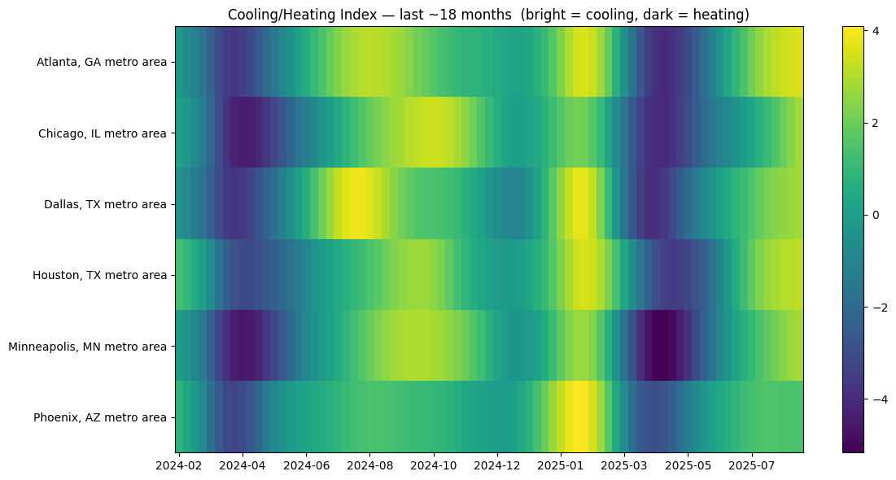
Market Cycle Analysis - Strategic Timing for iBuyers
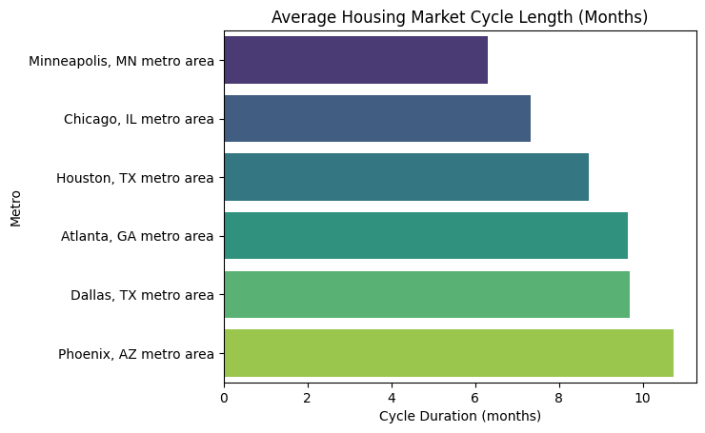
Metro | Avg. Cycle (Months) | Interpretation for iBuyers
Minneapolis, MN | ~6 | Short, efficient cycles - fast market corrections and quicker resale turnaround. Ideal for rapid flip models.
Chicago, IL | ~7 | Slightly longer cycles - price changes are gradual; predictable timing but slower capital recovery.
Houston, TX | ~8.5 | Mid-range cycles - moderate liquidity with seasonal sensitivity. Balance between quick resale and rental conversion.
Atlanta, GA | ~9.5 | Longer cycles - indicates steady demand but slower recovery. Focus on mid term holding (60–90 day rotations).
Dallas, TX | ~9.5 | Similar to Atlanta; boom bust sensitivity means timing entries around peak absorption phases is key.
Phoenix, AZ | ~10.5 | Longest and most volatile cycle - reflects high sensitivity to rate changes. Requires hedging or algorithmic entry timing.
Stability Overview
Metro | Stage2 Stability Score | Liquidity | Volume | Distress | Cycle Stability | Avg Cycle (months) | Interpretation
Minneapolis, MN | 0.64 | 1.00 | 0.00 | 0.47 | 1.00 | 6.3 | Most stable market with quick cycles and predictable trends; ideal for scaling core iBuyer operations.
Chicago, IL | 0.52 | 0.00 | 0.75 | 1.00 | 0.66 | 7.3 | Stable but lower liquidity; lower volatility suits conservative, steady flip models.
Houston, TX | 0.47 | 0.31 | 1.00 | 0.21 | 0.33 | 8.7 | High transaction volume, moderate distress; good for hybrid rent + resale.
Atlanta, GA | 0.43 | 0.31 | 0.82 | 0.43 | 0.16 | 9.6 | Balanced but slower cycles; viable for longer holding windows (60–90 days).
Dallas, TX | 0.20 | 0.22 | 0.36 | 0.01 | 0.15 | 9.7 | Cyclical and liquidity sensitive; riskier for short term flips, but scalable for dynamic pricing iBuyers.
Phoenix, AZ | 0.12 | 0.01 | 0.49 | 0.00 | 0.00 | 10.7 | Highly volatile; long cycles and high distress risk make it speculative for standard iBuyer models.

- Minneapolis emerges as the most stable iBuyer friendly metro followed by Chicago, offering the high liquidity, and predictable returns.
- Houston and Atlanta provide volume and steady demand, suitable for scaling with moderate risk.
- Dallas and Phoenix are volatile, slow recovering markets; best approached as testbeds for advanced predictive pricing models or hedge backed inventory strategies.
Overall, we see a trend that the metros in the states with higher appreciation and ROI are also topping in the market metrics.
Forward Outlook - Economic Adjustments & Buyer Persona Alignment
While the current Stage 2 Stability Scores are based primarily on housing market fundamentals (liquidity, volume, distress, and cycle stability), the next iteration of the model will incorporate appreciations, mortgage data, macroeconomic and demographic indicators that significantly influence iBuyer performance and risk.

Economic Factors to be Integrated (Stage 3 Enhancements)
- Employment Growth & Wage Trends: Markets with strong job creation and above average wage growth tend to sustain buyer demand and price resilience.
- Mortgage Rate Sensitivity: Captures how quickly each metro’s sales volume reacts to rate changes essential for predicting inventory absorption speed.
- Population & Migration Flows: Net inbound migration and household formation rates will refine volume potential and resale velocity estimates.
- Affordability Ratios: Linking income levels to median home prices will help estimate sustainable demand and price elasticity.
- Construction Permits & Supply Pipeline: Oversupply risks can dilute resale margins; integrating permit data helps anticipate future cycle shifts.
Result:
When these economic layers are added, Stage 3 Stability Scores will dynamically adjust to reflect real-time market resilience and risk appetite - shifting some metros upward (e.g., high growth Sunbelt regions) and others downward (e.g., affordability strained or low migration metros).
Projected Acquisition Volume and Capital Requirement

SmartSell plans to acquire between 100 and 200 residential properties across two metropolitan markets during its first operational year. With an average purchase price of $420,000 per home, the total acquisition cost is projected between $42 million (for 100 homes) and $84 million (for 200 homes). Including renovation, holding, and transaction expenses, the total property-related cost is estimated between $46 million and $94 million.

CONCLUSION
This interim report establishes a strong foundation for our ethical iBuyer concept. Our analysis clearly demonstrates that early home sellers face substantial financial risk under the current system, as equity accumulates slowly due to interest-heavy amortization. By combining partial co-investment, transparent decision support, and fast transaction execution, our model directly addresses these pain points while preserving customer wealth.
We have validated the market opportunity and identified promising metros for initial simulations. The next phase will finalize market selection, complete unit-economics modeling, and produce a 24-month financial projection to demonstrate sustainable revenue and responsible capital use. With data-driven strategy and disciplined deployment, we are well-positioned to prove that this model can deliver both strong customer outcomes and profitable growth.
NEXT STEPS
- Step 1 : Finalize Metro Selection
Objective: Choose 2–3 pilot metros that balance low downside + high turnover
- Step 2 : Define Unit Economics Per Transaction
Objective: Show how much profit per home we can earn
- Step 3 : Home Turnover Simulation
Objective: Show that we can quickly recycle capital
- Step 4 : Customer Volume Forecast
Objective: Show revenue scaling with limited metros
- Step 5 : Risk & Sensitivity Analysis
Objective: Prove the model works even in downturns
- Step 6 : 24-Month Pro Forma (Financial Projection)
Objective: Demonstrate solid profitability path with lean burn
- Step 7 : Final Recommendation & Path to Scale
Objective: Show the investor what’s possible after proving PMF

CODE AND REFERENCES
- https://nationalmortgageprofessional.com/news/survey-pinpoints-pain-points-home-sales
- https://ffiec.cfpb.gov/data-publication/modified-lar/2024
- https://www.redfin.com/news/data-center/
- https://data.census.gov/
- https://www.bls.gov/data/
- https://www.bankrate.com/real-estate/median-home-price/#how-much
- Code for all analysis available at - https://github.com/MeghaCNair/MetroAnalysis-RealEstate

Individual Contribution:
- Business Model and Market Analysis - Sriram Ganeshalingam
- Competitor Analysis and Sales & Marketing Strategy - Noah T. Brown
- Metro level Analysis - Megha Chandrasekharan Nair & Vishala Vemuri
- Macro-Economic indicator analysis and forecasting(Ongoing) - Megha Chandrasekharan Nair & Vishala Vemuri
- Cost Analysis(Ongoing) - Teja Kuragayalabathi

PROJECT PHASE 2 - IMPLEMENTATION

FORECASTING ECONOMIC INDICATORS
To identify the most strategically favorable U.S. metropolitan area for long-term investment, expansion, or targeted policy intervention, we developed a comprehensive, multi-factor forecasting framework that evaluates each metro across six forward-looking indicators: migration, total population, prime-age population (25–44), median household income, unemployment rate, and housing prices. Each metric was projected into the future using advanced statistical and machine-learning models, enabling a forward-looking, risk-adjusted comparison rather than relying on historical performance alone.
To combine these separate forecasts into a single, decision-ready outcome, a weighted scoring model was applied. Each metric was assigned a business-defined weight representing its relative importance in the final metro recommendation. These weights allow stakeholders to prioritize economic growth, labor force strength, affordability, or stability based on strategic goals.

1. Migration Forecast
Net migration reflects the attractiveness of a region by capturing whether people are moving into or out of it. Using IRS county-to-county migration data (2011–2022), we mapped county movements to metro CBSAs and computed annual inflows, outflows, and net migration for five major metros: Atlanta, Chicago, Dallas, Houston, and Minneapolis.
To forecast future migration trends, we employed a hybrid modeling approach that evaluated Holt’s exponential smoothing, auto-ARIMA, and tuned Prophet models for each metropolitan area. The best model per metro was selected using MAPE, ensuring the most accurate forward projection. Net migration was forecast through 2027, allowing us to score metros on future population attraction,a strong indicator of economic vitality, business growth, and labor availability.
2. Total Population Forecast
Long-term population scale supports consumer demand, labor availability, infrastructure planning, and market size estimation. Using ACS population data (2010–2024), we built metro-level time series for six metros and projected populations through 2027 using a damped-trend exponential smoothing model.
To ensure accuracy, forecasts were bias-corrected using the deviation between the 2024 actual and fitted values. This produced a reliable population trajectory that informs how large and stable each metro’s consumer and labor base will be over the next three years.
3. Prime-Age Population/Persona (25–44) Flow Forecast
The 25–44 cohort is the backbone of economic productivity , representing the majority of workforce participants, homebuyers, new movers, and high-consumption households. Using ACS mobility data (2010–2024), we constructed an annual panel that estimated prime-age movers per metro.
To project future inflows, we evaluated damped Holt and auto-ARIMA models, selecting the best performer for each metro through validation MAPE. Forecasts for 2025–2027 quantify how strongly each metro can attract or retain working-age talent, a critical component in economic competitiveness and business site selection.
4. Income Forecast
Median household income is a key proxy for consumer purchasing power, tax base strength, and overall economic resilience. ACS income data (2010–2024) was cleaned and consolidated into a metro-level panel. To forecast future income:
- CPI-based inflation forecasts (via SARIMA) were generated through 2027.
- Multiple SARIMAX models were tested for U.S. income with inflation as an exogenous input.
All SARIMAX models failed, so U.S. income was ultimately forecast using ARIMA(1,1,1).
- The resulting U.S. income and inflation forecasts were then used as exogenous drivers for metro-level SARIMAX models, producing income projections through 2027.
These income forecasts capture expected metro-level shifts in household purchasing power, economic stability, and wage competitiveness.
5. Unemployment Forecast
Unemployment forecasts indicate economic risk, business cycle exposure, and labor market stability. We collected monthly unemployment data from the BLS LAUS program for six metros and aligned the series into a monthly panel.
To integrate macroeconomic shocks, we merged CPI data and constructed binary indicators for the 2008 recession and 2020 pandemic. These crisis signals were used as exogenous regressors in SARIMAX models.
Each metro’s unemployment rate was forecast for 2025–2027, enabling a forward-looking comparison of economic vulnerability and workforce stability across regions.
6. House Price Forecast
Housing affordability is a key factor in talent attraction, business relocation decisions, and cost-of-living assessments. Using weekly Zillow median sale price data, we filtered the data to target metros and cleaned it to a weekly frequency.
A tuned Prophet model was applied to each metro, using a rolling-origin validation approach with MAPE as the selection criterion. The best model per metro produced 104-week forward forecasts, which were then aggregated into annual median price projections for 2025–2027.
These housing forecasts help evaluate affordability risks, real estate pressure, and cost-of-living barriers for future workforce inflow.

METRO FINALIZATIONS
To compare the six pilot metros on a consistent basis, we constructed a composite iBuyer Attractiveness Score using a weighted combination of economic, housing, and demand-side indicators.
First, each underlying factor was min–max normalized to remove differences in units and scales.
This was applied to:
- Median household income (Income_norm)
- Median house price (Houseprice_norm)
- Net migration (Migration_norm)
- Persona-based “move-in potential” score (PersonaMovein_norm)
- Population size (Population_norm)
Unemployment was treated as a risk factor. Instead of using the raw unemployment rate, we worked with the employment rate by inverting the series (1 - unemployment) and then normalizing it. This ensures that higher values consistently represent more favorable conditions across all factors.
We then combined these normalized variables with the previously computed Stage 2 Stability Score to obtain a single Final iBuyer Score for each metro year observation:
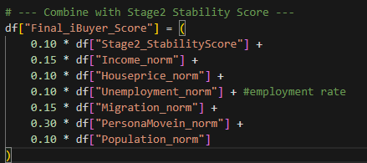
The weights reflect our strategic priorities:
- High weight on demand-side intent (PersonaMovein_norm, 0.30) and migration flows (0.15), since they directly capture the likelihood of near-term transactions and churn.
- Moderate emphasis on income, employment, and population (0.15, 0.10, 0.10), which influence affordability, credit quality, and market depth.
- Lower, stabilizing contribution from Stage2_StabilityScore (0.10) and house prices (0.10), which reflect market resilience and price environment without dominating the score.
After computing the Final iBuyer Score for each metro and year, we ranked metros in descending order of this score. To smooth out year-to-year volatility and focus on durable attractiveness, we then calculated a two-year average score per metro:
Finally, we sorted metros by this averaged score.
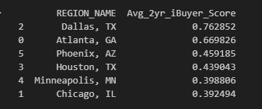
In our current data, Dallas and Atlanta emerge as the top two markets, followed by Phoenix, Houston, Minneapolis, and Chicago, indicating that Dallas and Atlanta provide the most attractive combination of stability, demand, liquidity, and growth potential for an iBuyer-style entry over the next two years.

We also dived into zip-code level analysis, but the zip-code level market indicators were not available. We finally used ZHVF, which is Zillow Home Value Forecast to understand appreciation levels of each zip code and scored them based on stability and growth. But we observed that these zip codes might not be very iBuyer friendly since we do not know other market indicators like inventory size, median days on market etc. So, going forward for our financial statements we have considered median values of Dallas in general rather than focusing on zip codes.
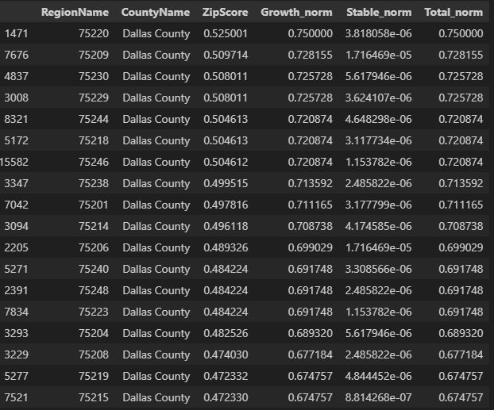

OUR SUBSCRIPTION BASED PLATFORM TO EMPOWER HOMEOWNERS
LINK: https://smartsell-app.vercel.app/
SmartSell positions itself as a next generation iBuyer platform designed not only to provide instant cash offers, but to give homeowners full transparency, optionality, and long-term financial guidance throughout the selling journey. Unlike traditional iBuyers that focus narrowly on fast transactions, SmartSell integrates marketplace reach, financial intelligence, and service orchestration into a unified experience,ensuring homeowners who stay in control of every decision.
A Comprehensive, End-to-End Home Selling Ecosystem
SmartSell extends the classic iBuyer model with four integrated pillars:
- Instant Cash Offers
  - AI-enabled underwriting delivers competitive cash offers within minutes.
  - Risk flags, comps, and profit guardrails ensure accurate and responsible valuation.
- Marketplace Syndication
  - Sellers can sell strategically instead of selling blindly.
  - With one click, listings reach partner agents, institutional buyers, and SmartSell’s internal network.
- Education & Decision Guidance
  - A dedicated “Education Studio” provides short, branded explainers on escrow, refinancing, maintenance, and tax implications.
  - Scenario simulators allow sellers to model hold vs. sell, refinance, or rent outcomes using real-time rates and appreciation curves.
- Service & Concierge Network
  - A curated vendor marketplace offers vetted maintenance crews, staging services, inspectors, and post-close specialists.
  - SmartSell manages coordination end-to-end, so the property stays transaction-ready.
Together, these pillars allow teams to convert, educate, and support homeowners without stitching together third-party tools.
Financial Clarity at Every Step
One of SmartSell’s signature features is its focus on equity intelligence and financial transparency:
- Live valuation, mortgage balance, and unlockable equity are surfaced in real time.
- Escrow forecasting models taxes, insurance, and HOA changes to show evolving monthly payments.
- Scenario sliders allow sellers to adjust hold periods, market appreciation, rent comps, or refinance incentives,helping them understand exactly when selling produces better outcomes than renting or refinancing.
This transforms the seller’s experience from guesswork into guided decision-making.

A Trusted Operational Network Behind Every Transaction
SmartSell strengthens its value with a robust operational backbone:
- Maintenance & Repair Crews: Vetted professionals dispatched for tune-ups, punch lists, and emergency fixes.
- Make-Ready Concierge: Bundled cleaning, landscaping, staging, and photography with milestone tracking.
- Post-Close Loyalty Programs: Warranty upsells, seasonal maintenance plans, and homeowner check-ins that nurture long-term relationships.
This ecosystem ensures the property remains ready for the market and that SmartSell stays engaged well beyond the transaction.

Unified Workspaces for Sellers and Buyers
SmartSell provides role-specific interfaces that streamline collaboration:
Seller Workspace
- Track instant offers, marketplace performance, equity position, and required service orders.
- View financial projections, receive offer updates, and schedule concierge services without leaving the dashboard.
Buyer Workspace
- Personalized feed of concierge-prepared homes.
- Scenario-based financing lane compares fixed-rate, ARM, and bridge options.
- Activity timeline keeps buyers aligned across agents, co-buyers, and inspectors.
- Rate-lock reminders, disclosure packets, and tour itineraries ensure no step is missed.
The result is a fluid transaction experience where all stakeholders collaborate in a single environment.

Positioning & Value Proposition
SmartSell’s core differentiation lies in its threefold value proposition:
- Transparency: Real financial modeling gives homeowners clarity on true net proceeds, holding costs, and equity unlock scenarios.
- Lifetime Guidance: Education tools, ongoing maintenance plans, and financial projections establish SmartSell as a long-term partner, not just a bidder.
By combining underwriting, marketplace syndication, financial simulations, and operational services, SmartSell reimagines the iBuyer model as a full-stack homeowner guidance platform.

PRIMARY KPIs RANKED
- Average Gross Profit Per Unit: Primary source of income for our company. Measuring this gives us an idea of how much we take away from each home transaction.

- Average Days to Sell: Measures the time from purchase to final sale. Speed is the essential to our business model to minimize holding costs (property taxes, insurance, capital costs).

- ROI on Renovation/Capex: Tells us how profitable our renovations are, if at all. This is important in telling us what renovations are worthy of consideration, given average returns and how their timeline contributes to appreciating holding costs.

- Total Subscriptions, Growth Rate, and Subscription Revenue: Tracks Metrics for our subscriptions. Which can let us know if we need to change certain aspects of our subscription model like pricing, services provided, etc. for the purpose of maximizing revenue.

- Holding Costs as % of Final Sale Value: Holding costs (taxes, insurance, utilities, debt servicing/interest payments) eat into our profits for as long as a home sits around in our inventory. This puts that reduction in profits as a percentage of the whole of the final sale, to see how much of that final selling price we lost to holding costs.

- Net Profit Margin: Similar to Gross Profit Per Unit, but for all our business operations. Producing a lot of Revenue is important, especially for a growing business, but making sure those values exceed required costs is equally essential in the long term.

- Total Revenue: Our overall income. Maximizing this number is key to any company’s successful business growth.

- Return on advertising spending: Measures of how much the profit we get from business generated from marketing exceeds our ad spend.

- Customer Acquisition Cost: The overall price we must pay to attract mainly home sellers, but also buyers and subscribers for our subscription service.

- Operations Growth Rate: Good for measuring the overall scope and scale of our business, and how well our operations are expanding.

COST ANALYSIS AND FINANCIAL STATEMENTS

ACQUISITION & PROFITABILITY MODEL – YEAR 2026 and 2027 PLAN

To determine realistic acquisition targets for Dallas and Atlanta, we benchmarked against Offerpad’s 2024 volume of 2,443 homes across 14 markets. We allocated these purchases across metros using Zillow’s annual Sales Count (Nowcast), which estimates total yearly transaction activity by adjusting for reporting lag.
Using each metro’s share of annual sales:
- Dallas’s implied capacity ≈ 318 homes/year, so we selected a conservative 300-home target for Phase 1.
- In Phase 2, Dallas is scaled to 200 homes (~⅔ of Phase 1) to balance resources during multi-market operations.
- Atlanta’s implied capacity ≈ 360 homes/year, but as a new expansion market, we targeted 180 homes (50% of full capacity) to ensure controlled, manageable growth.

Relevant links –
- https://www.offerpad.com/locations/
- https://www.sec.gov/Archives/edgar/data/1825024/000119312525033395/d931901dex991.htm

This approach grounds our acquisition volumes in real market absorption, industry benchmarks, and prudent operational ramp-up, resulting in a two-year plan of 300 homes in Year 1 and 380 homes in Year 2.
Our model applies tier-based assumptions to reflect differences in pricing, renovation scope, and resale behavior. Tier 1 homes receive the highest renovation and uplift percentages because they require more improvements, and these upgrades directly contribute to the increased selling price. Tier 2 and Tier 3 follow the same decreasing pattern, consistent with their lower renovation needs. Holding periods vary by tier, and monthly carrying costs, including insurance, property tax, HOA dues, and maintenance, capture realistic ownership expenses in Dallas and Atlanta.

Transaction fees are simplified to a 1% internal closing cost at both purchase and sale, covering expenses like title, escrow, recording, and administrative processing. We chose 1% because it reflects the lower, streamlined closing costs typical of an iBuyer model while keeping our assumptions conservative. The customer-facing fee is the service fee of 4 to 4.25%, which remains below the traditional 6% agent commission and reflects the value of our full-service, simplified buying and selling experience. Together, these assumptions create a consistent and practical cost-revenue framework across Phase 1 and Phase 2, including inflation adjustments for Dallas and higher renovation/uplift expectations for Atlanta.

1. PHASE SUMMARY
Phase | Market(s) | Homes | Service Fee (Buy/Sell) | Purpose
Phase 1 | Dallas | 300 | 4% / 4% | Pilot + ramp-up
Phase 2 | Dallas + Atlanta | 380 (200 Dallas + 180 Atlanta) | 4.25% / 4.25% | Expansion + scaling

2. PRICE, RENOAVATION, UPLIFT, APPRECIATION
2.1 Baseline Prices
Market | Tier 1 | Tier 2 | Tier 3
Dallas | $338,000 | $443,000 | $676,000
Atlanta | $305,000 | $405,000 | $630,000

2.2 Renovation %
Phase | Market | Tier 1 | Tier 2 | Tier 3
Phase 1 | Dallas | 8% | 6% | 5%
Phase 2 | Dallas | 8% × 1.0223 | 6% × 1.0223 | 5% × 1.0223
Phase 2 | Atlanta | 10% | 8% | 6%

2.3 Uplift (Accounting for inflation in Year2 for Dallas) %
Phase | Market | Tier 1 | Tier 2 | Tier 3
Phase 1 | Dallas | 8% | 6% | 5%
Phase 2 | Dallas | 8% × 1.0223 | 6% × 1.0223 | 5% × 1.0223
Phase 2 | Atlanta | 9% | 7% | 6%

2.4 Appreciation % (Annual)
Market | Tier 1 | Tier 2 | Tier 3
Dallas | 4% | 4.5% | 5%
Atlanta | 3% | 3.5% | 4%

3. HOLDING COST ASSUMPTIONS
Market | Insurance (Annual %) | Property Tax (Annual %) | Maintenance (Monthly) | HOA (Monthly)
Dallas | 0.40% | 1.80% | $60 | $50
Atlanta | 0.50% | 1.10% | $50 | $40

4. TRANSACTIONAL COSTS
Transaction Type | Phase 1 | Phase 2
Buy Transaction Cost | 1% | 1%
Sell Transaction Cost | 1% | 1%

5. SERVICE FEE STRUCTURE
Phase | Market(s) | Buy Fee | Sell Fee
Phase 1 | Dallas | 4% | 4%
Phase 2 | Dallas + Atlanta | 4.25% | 4.25%

6. HOLDING PERIOD ASSUMPTIONS
Market | Tier 1 | Tier 2 | Tier 3
Dallas | 3–6 months | 4–7 months | 5–8 months
Atlanta | 4–7 months | 5–8 months | 6–10 months

7. HOUSE DISTRIBUTION
7.1 Phase 1 , Dallas (300 homes)
Tier | Count | %
Tier 1 | 105 | 35%
Tier 2 | 153 | 50%
Tier 3 | 42 | 15%

7.2 Phase 2 , Dallas (200 homes)
Tier | Count | %
Tier 1 | 50 | 35%
Tier 2 | 73 | 51%
Tier 3 | 22 | 14%

7.3 Phase 2 , Atlanta (180 homes)
Tier | Count | %
Tier 1 | 50 | 47%
Tier 2 | 53 | 44%
Tier 3 | 17 | 9%

7.4 Combined Portfolio Distribution (680 total homes)
Market | Tier 1 | Tier 2 | Tier 3 | Total
Dallas Phase 1 | 105 | 153 | 42 | 300
Dallas Phase 2 | 70 | 102 | 28 | 200
Atlanta Phase 2 | 84 | 79 | 17 | 180
Grand Total | 259 | 334 | 87 | 680

Marketing Outline
Ultimately, we decided to go with outsourcing online marketing endeavors to 3rd party professionals at WebFX as it is a cheaper, more convenient, and more reliable choice as opposed to hiring, training and upholding in-house professionals that we would pay annual salaries to. WebFX proved to be the most versatile and capable option compared to its competitors, with the best resources to help a larger corporation like us to get into the market quickly.

Year 1: Entering the Market
We want to make a strong entrance into the Dallas market, to which end we will need to immediately establish our presence through intensive advertising and marketing. Initial setup costs will be fairly high, and monthly costs vary widely based on the services we use and state of business, meaning we can scale our ad spend and WebFX commissions based on evolving business needs to maximize profits.
Price Breakdown:
Service | Cost | Recurrence
Website and Platform Development | $50K - $150K | Single Initial Setup Cost
Digital Marketing Operations | $25K - $60K | Monthly Fee
Pay-Per-Click Management | 15% of total ad spend  ($15K - $45K) | Monthly Fee
SEO and Content Marketing | $10K – $25K | Monthly Fee
Customer Review and Feedback Monitoring | $3K - $8K | Monthly Fee
Monthly Ad Spend | $100K - $300K | Monthly Spending
Total Monthly Costs | $153K - $438K* | Monthly Spending
*Total Monthly Cost excludes one time setup costs for website creations and other commissioned projects

Year 2: Continued Operations and Moving into a Second Metro
After getting comfortable in the first market and establishing smooth operations there, we can move into a second market. We will be saving on some of the initial setup costs of our business we needed in year 1, but general upkeep of marketing in 2 regions becomes larger as we have to expand the services we request from WebFX. We will maintain an overall ad spend range from $100K to $300K independently per metro, once again as evolving business needs demand in each metro.
Price Breakdown:
Service | Cost | Recurrence
New Metro Website/Service Adaptation + Localization | $15K - $40K | One-Time Project Fees
Digital Marketing Operations | $40K - $90K | Monthly Fee
Pay-Per-Click Management | 15% of total ad spend  ($30K - $90K) | Monthly Fee
SEO and Content Marketing | $10K – $25K | Monthly Fee
Customer Review and Feedback Monitoring | $5K - $10K | Monthly Fee
Monthly Ad Spend | $200K - $600K | Monthly Spending
Total Monthly Costs | $285K - $815K* | Monthly Spending
*Total Monthly Cost excludes one time setup costs for website creation and other commissioned projects
Information on pricing for WebFX and considered competitors can be found here:
https://www.webfx.com/web-design/pricing/website-costs/
https://www.webfx.com/digital-marketing/pricing/
https://www.embarque.io/post/webfx-review
https://vwo.com/blog/web-design-statistics/
https://www.nutshell.com/marketing-services/seo-services

THE THREE FINANCIAL STATEMENTS

All the breakdown costs and related files are uploaded in the box folder. Since it was hard to show everything in the report.
LINK: https://utdallas.box.com/s/axnxfoedjvhctyc4a0ivaqjxiw141h1k

BALANCE SHEET FOR YEAR 1 JAN 2026 – DEC 2026
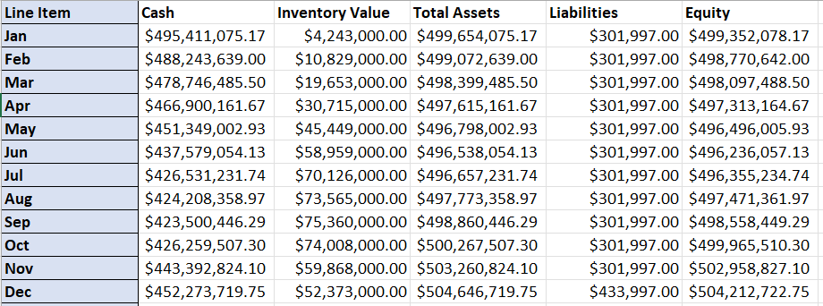

INCOME STATEMENT FOR JAN 2026 TO DEC 2026
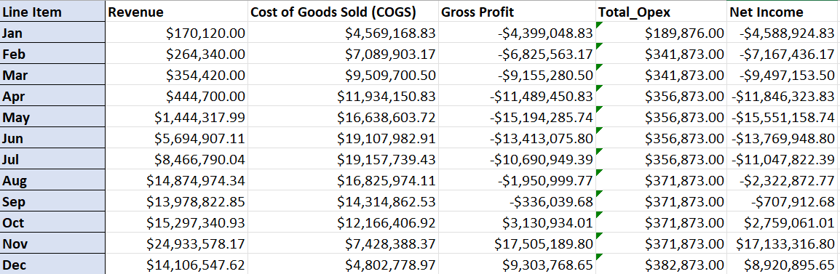

CASH FLOW FOR JAN2026 TO DEC 2026
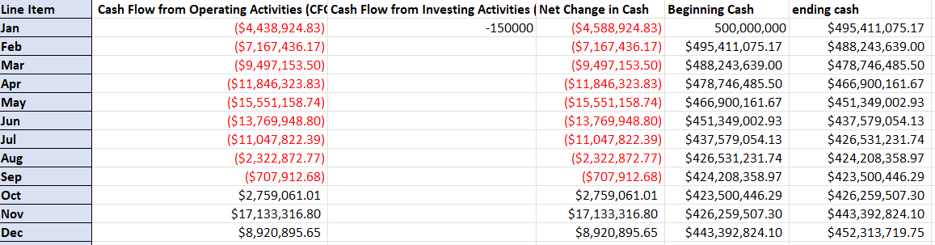

BALANCE SHEET FOR JAN2027 TO DEC 2027
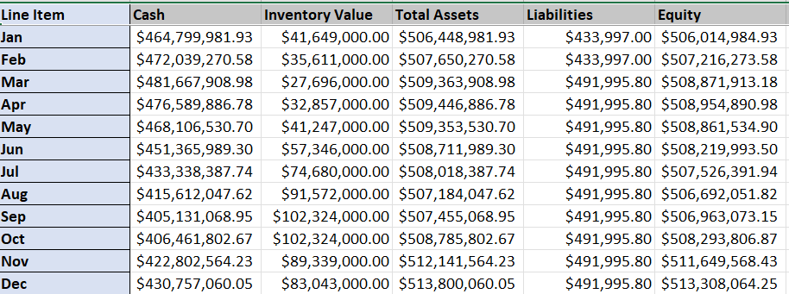
INCOME STATEMENT FOR JAN2027 TO DEC 2027
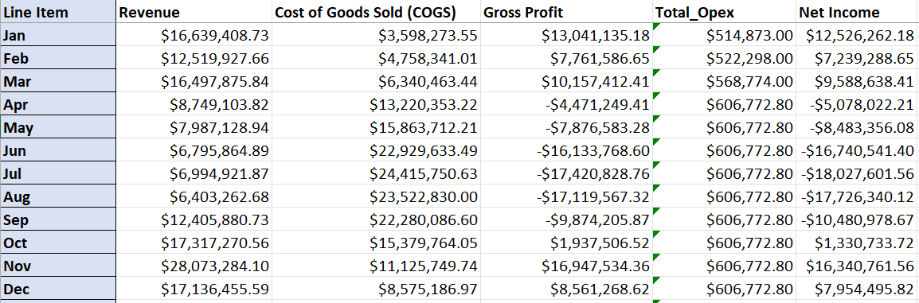
CASH FLOW FOR JAN2027 TO DEC 2027
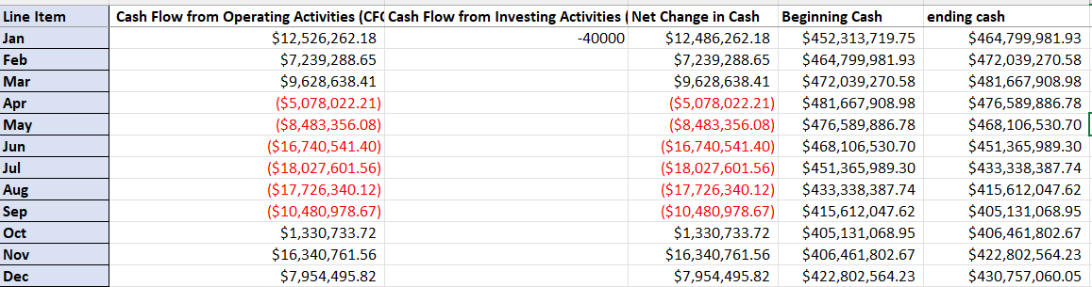

BALANCE SHEET FOR JAN2028 TO SEP 2028
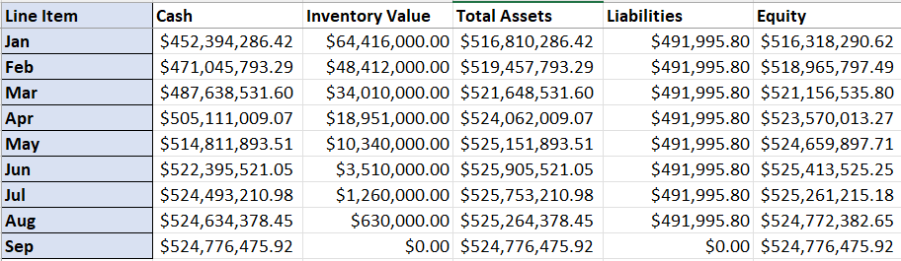
INCOME STATEMENT FOR JAN2028 TO SEP 2028
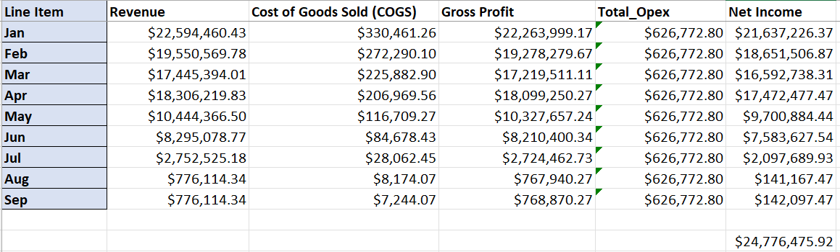
CASH FLOW FOR JAN2028 TO SEP 2028
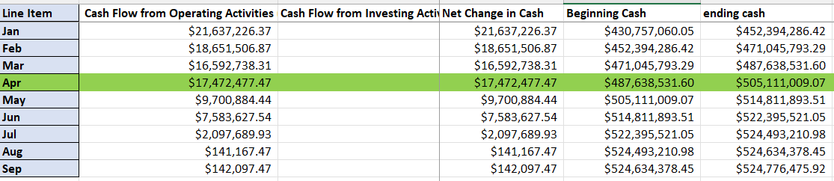

We can observe from the last column that we have a positive final net cashflow in the 28th month of starting our business. After deducting the tax around 21%. We will be having a an ROI of around 19% by September of 2028(3rd year).
UPDATED MODEL AFTER ACCOUNTING FOR CERTAIN LOSSES
To model realistic liquidation losses at the house level, we began with Offerpad’s reported Q3 2025 loss rate of 8.75% and scaled it down to reflect our more conservative operating assumptions—using 5.5% for Year 1, 5.5% for Year 2, and 5.0% for Year 3 as the overall annual loss targets. At the property level, we applied a two-step framework using Base Rates and Season Multipliers. Each home was first assigned a Base Rate based on its tier (Tier 1 = 4%, Tier 2 = 7%, Tier 3 = 12%), representing the expected relative risk across entry-level, mid-range, and high-end homes. This base loss rate was then adjusted using a Season Multiplier to reflect the month of sale—homes sold in strong selling periods like April–July receive smaller discounts (0.85×), while those sold in slow months such as November–February face higher liquidation pressure (1.25×). The combination of these two factors produced each home’s raw loss estimate, which was then proportionally scaled so that the aggregate losses for each year matched the 5.5%, 5.5%, and 5.0% annual loss assumptions. This approach preserves realistic differences in risk by home type and season while ensuring alignment with the overall yearly financial targets.

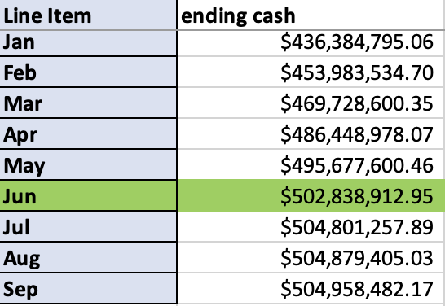

INDIVIDUAL CONTRIBUTIONS

VISHALA VEMURI | - Economic indicator forecasting  - House buying and selling breakdown for financial statements.
NOAH D BROWN | - Interim report feedback incorporations  - Marketing cost outline  - Identifying Primary KPIs
MEGHA C NAIR | - Finalize metro based on economic indicators & Zip code analysis  - Web App Development  - Integrating content into final report and PPT creation
SRIRAM G | - Creating the balance sheet and income statement
TEJA K | - Labor and employee salary and cost breakdown  - Cash Flow statement

CODE AND REFERENCES
- https://nationalmortgageprofessional.com/news/survey-pinpoints-pain-points-home-sales
- https://ffiec.cfpb.gov/data-publication/modified-lar/2024
- https://www.redfin.com/news/data-center/
- https://data.census.gov/
- https://www.bls.gov/data/
- Code for all analysis available at - https://github.com/MeghaCNair/MetroAnalysis-RealEstate

